**LAB #05**: **DHCP and DNS Configuration**

**DHCP** Stands for dynamic host configuration protocol, it is a network management protocol used mainly to distribute IP address to all connected devices in a network. when ever a system is turned on in a network it sends a request to server this request is called **DHCP DISCOVER**, on receiving the request it supplies the client with a IP address from its pool this offer is called **DHCP OFFER**, on receiving the offer the client responds with the packet called **DHCP REQUEST** to eventually get the IP.

1. Select 3 PCs and a server from “End Devices” your work area will look like this.

Figure1: Place Devices

1. Choose “Connection Type” to connect these devices with HUB.
2. Now click on all three PCs
3. Go to “DESKTOP”
4. Then “IP CONFIGURATION”
5. Here select option “DHCP” instead of assigning IP Address Statically
6. Now click the Server

Figure 2: Connected Devices

1. The screen you will see will look some thing like this:

Figure 3: Depicting Server Setting

1. Above diagram shows the screen which you will see on clicking “SERVER” Machine.
2. Here go to Fast Ethernet placed just under Interface marked with red.
3. After clicking “Fast Ethernet” you will see following window. Here assign IP ADDRESS to this SERVER.

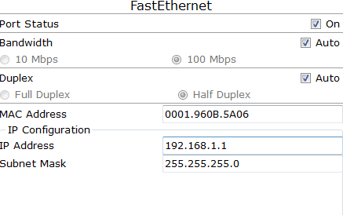

Figure 4: Setting IP Address

1. Now click “DHCP” to make this server a DHCP server.

Figure 5: Selecting DHCP as a server

1. DHCP is “Dynamic Host Configuration Protocol” a DHCP server is responsible for Assigning IP Addresses to the devices present in the Network from its pool. This Concept can be seen in the image shown below.

Figure 6: Turn on Service

1. now each device will take IP from DHCP

# CONFIGURATION OF DNS

DNS is” Domain Name Services” server the main purpose of this server is to resolve domain name against its allocated IP address. Humans can recognize a name that’s why we give names to web sites or locations in networks but actual destination is located through IP address which is a sequence of numbers and is very difficult for an individual to remember.

**Example:** It is easy to remember [**www.yahoo.com**](http://www.yahoo.com/) then 87.248.113.14

Figure 7: Turning DNS ‘on’ and defining name translation.

GO TO “FAST ETHERNET” of DNS and assign this server IP address **192.168.1.8**

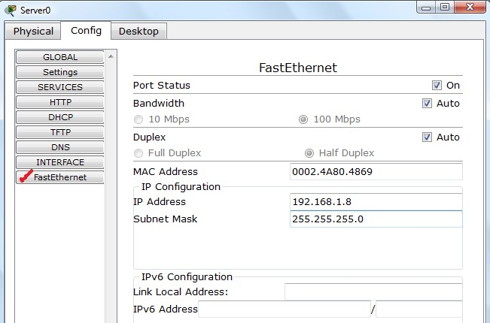

Figure 8: Set IP Address

Figure 9: Introducing DNS Server

1. Mention this IP Address of DNS at DHCP server as well. Look at the previous screen shot where we have discussed DHCP server there the slot of DNS server is empty, because we have no DNS server in our network but once you will introduce a DNS server you will have to give its Address at DHCP server.
2. Now after creating DNS server the DNS Packets should also travel successfully

**Lab Tasks**

Create the following network with DHCP server. Send DNS packets in your network